ONLINE VOTING :

ADD PARTIES

ADD COMING VOTES

ADD PARAMETERS

ADMIN : ADD PARTIES : PARTY NAME ,RELATED LOGO

ADD UPCOMING ELECTION: Election Title , ELECTION DESCRIPTION , START DATE ,ELECTION CITY ,State



USER : HOME , USER REGISTRATION , COMING ELECTION , ELECTION POLLS , ELECTION RESULT , SIGN IN , SIGN UP



HOME : MENU , SLIDER ,PARTIES , LATEST USER COMMENTS , RIGHT 2 VOTE , FOOTER



MENU , HEADER

<https://eci.gov.in/>



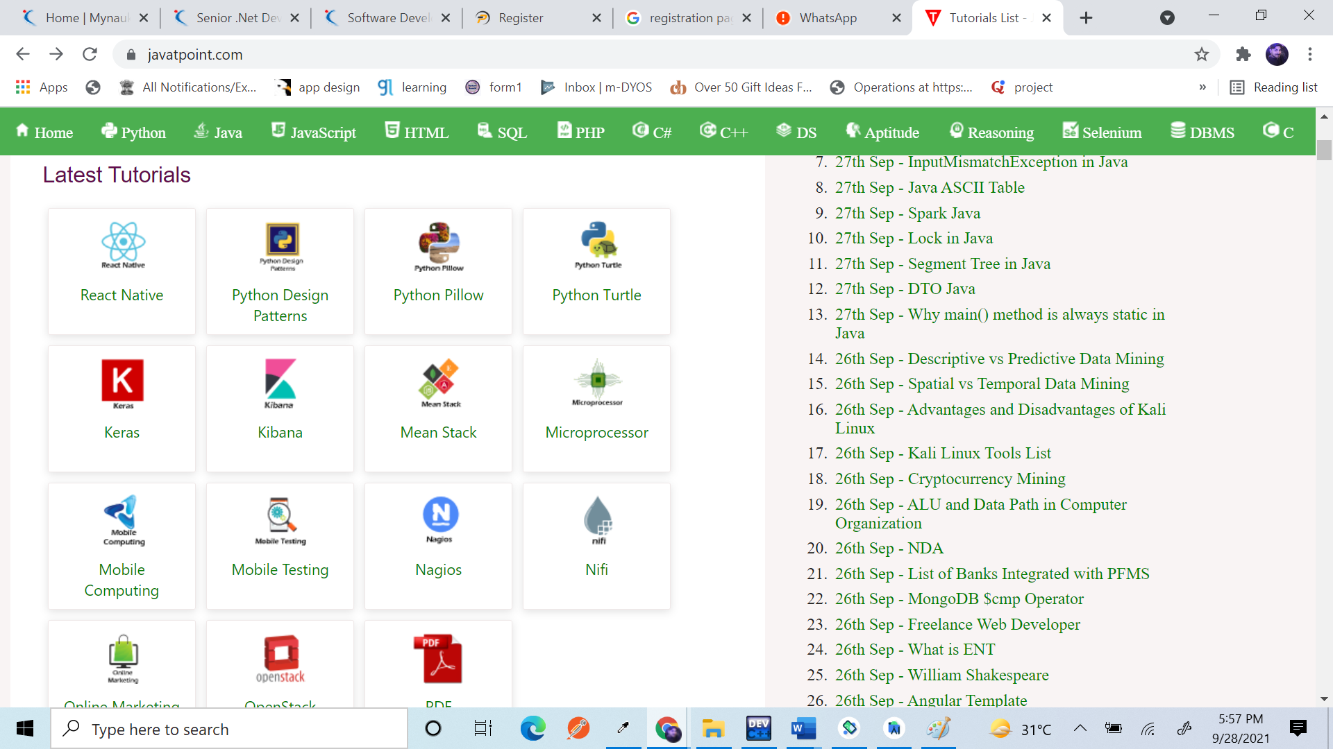

2. Registration / Sign Up / Voter Registration :



Name ,

Gender

Dob

Contact number

Adhar Number

Password

State

City

Profile Picture

Registration Date